- Appliation auto scaling
  - Cho phép tự động scale các service liên quan tới EC2
Các service: https://docs.aws.amazon.com/autoscaling/application/userguide/integrated-services-list.html

- Config
  - https://docs.aws.amazon.com/autoscaling/application/userguide/integrated-services-list.html
  - Auto scaling console
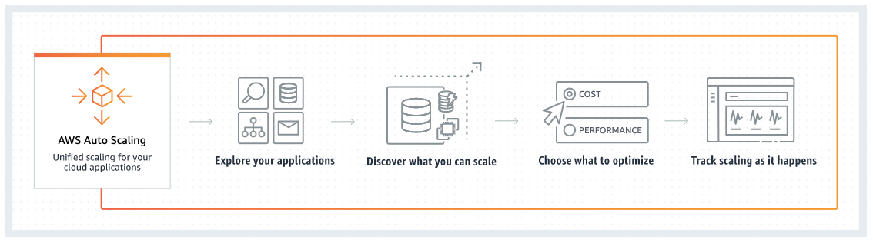
https://docs.aws.amazon.com/autoscaling/plans/userguide/auto-scaling-getting-started.html

- Reference
https://docs.aws.amazon.com/autoscaling/application/userguide/what-is-application-auto-scaling.html

